# Download Data from CEO

1. Log into CEO, http://ceo.sig-gis.com/.
2. Go to the Institution page.
   1. The list of institutions is located on the home page. Click on the blue ‘i’ next to your institution.
3. Click on the Edit button next to the completed project to download the data.
4. Note, you will need to be an institution admin to access the project edit screens.
5. Select on the DOWNLOAD PLOT DATA button.
6. If it opens the csv in the web browser, right click on the browser window and select **Save as…**
7. Save the csv into your project folder on your desktop where you have your github files saved (e.g., Desktop\LandCoverMonitoring\AccuracyAssessment\Data\CountryFiles).
8. Repeat to get data from other data collection projects.

# Sample the Primitive Values at each point

1. Save the csv as a fusion table by following the prompts at this link: <https://fusiontables.google.com/DataSource?dsrcid=implicit>
2. Copy the Fusion table ID (see image below).



1. Then update line 18 of this Earth Engine script to include the updated Fusion Table: <https://code.earthengine.google.com/772b02a97c2ebc10d3447446d95daa97>

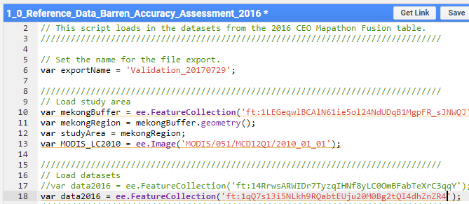

1. Click Run. Then in the Tasks bar, export the Validation data set. A new csv will be saved in your Google Drive with both the primitive and CEO values.
2. Go to your Google Drive and download the new data set (you can sort by last modified to locate it). Save it in your project folder in the folder ‘Data’.

# Merge Data Sets for each Country from CEO and add in Primitive Values

Do this is you want to run an accuracy assessment for the whole region, not just for one country.

1. Open the data prep R script, called MergeData.R
2. Modify line one so that the variable ‘Working Directory’ is set as the path to your project folder that contains the csv sheets with the accuracy assessment data for each country.
   1. Make sure that the slashes are either double back slashes (\\) or one single forward slash (/).
3. Then run the script. This will read all the csv’s in the ‘Data/CountryFiles’ folder and merge them into one large data base with a new column added that contains information about the country. Then it is written out as a new csv in the folder called ‘Data’.

# Assess accuracy of the primitives

Next…